**1. List the book title and retail price for all books with a retail price lower than the average retail price of all books sold by JustLee Books.**

SELECT title, retail "Lower than average"

FROM books

WHERE retail < (SELECT AVG(retail)

FROM books);

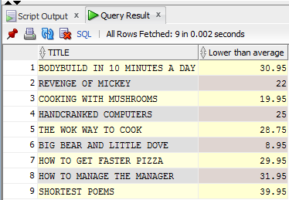

**2. Determine which books cost less than the average cost of other books in the same category.**

SELECT a.title, b.category, a.cost "LESS THAN AVG IN CATEGORY"

FROM books a, (SELECT category, AVG(cost) avgcost

FROM books

GROUP BY category) b

WHERE a.category = b.category

AND a.cost < b.avgcost;

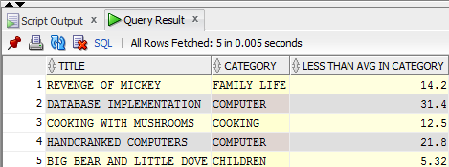

**3. Determine which orders were shipped to the same state as order 1014.**

SELECT order# "ORDERS: SAME STATE AS 1014"

FROM orders

WHERE shipstate = (SELECT shipstate

FROM orders

WHERE order# = 1014);

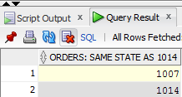

**4. Determine which orders had a higher total amount due than order 1008.**

SELECT order#, SUM(quantity * paideach)"ORDERS: TOTAL AMNT > 1008"

FROM orderitems

GROUP BY order#

HAVING SUM(quantity * paideach) > (SELECT SUM(quantity * paideach)

FROM orderitems

WHERE order# = 1008);

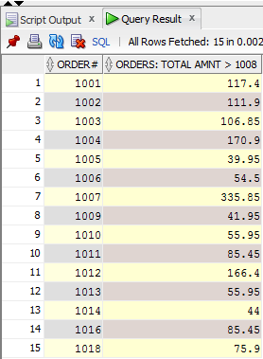

**5. Determine which author or authors wrote the books most frequently purchased by customers of JustLee Books.**

SELECT lname, fname

FROM bookauthor JOIN author USING(authorid)

WHERE isbn IN (SELECT isbn

FROM orderitems

GROUP BY isbn

HAVING SUM(quantity) = (SELECT MAX(COUNT(*))

FROM orderitems

GROUP BY isbn));

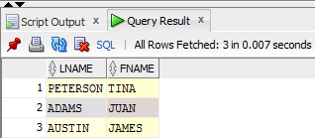

**6. List the title of all books in the same category as books previously purchased by customer 1007. Don’t include books this customer has already purchased.**

SELECT title "PURCHASED BY CUSTOMER 1007"

FROM books

WHERE category IN (SELECT DISTINCT category

FROM books JOIN orderitems USING(isbn)

JOIN orders USING(order#)

WHERE customer# = 1007)

AND isbn NOT IN (SELECT isbn

FROM orders JOIN orderitems USING(order#)

WHERE customer# = 1007);

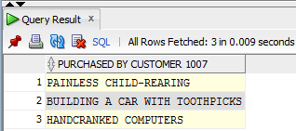

**7. List the shipping city and state for the order that had the longest shipping delay.**

SELECT shipcity, shipstate

FROM orders

WHERE shipdate-orderdate = (SELECT MAX(shipdate-orderdate)

FROM orders);

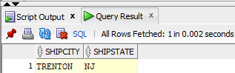

**8. Determine which customers placed orders for the least expensive book (in terms of regular retail price) carried by JustLee Books.**

SELECT customer# "ORDERS: LEAST EXPENSIVE BOOK"

FROM customers JOIN orders USING(customer#) JOIN orderitems USING(order#) JOIN books USING(isbn)

WHERE retail = (SELECT MIN(retail)

FROM books);

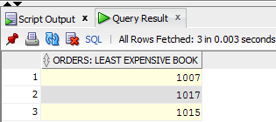

**9. Determine the number of different customers who have placed an order for books written or cowritten by James Austin.**

SELECT COUNT(DISTINCT customer#)

FROM orders JOIN orderitems USING(order#)

WHERE isbn IN (SELECT isbn

FROM orderitems JOIN bookauthor USING(isbn)

JOIN author USING(authorid)

WHERE lname= 'AUSTIN'

AND fname = 'JAMES');

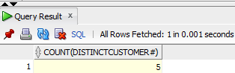

**10. Determine which books were published by the publisher of The Wok Way to Cook.**

SELECT title "PUBLISHER: The Wok Way to Cook"

FROM books

WHERE pubid = (SELECT pubid

FROM books

WHERE title = 'THE WOK WAY TO COOK');

